BUG REPORT

VWO.com

|  |  |  |
| --- | --- | --- |
| Bug Id | Description | Severity |
| TC-03 | Email validation is not mentioned | Major |
| TC-05 | Account is created even without selecting Privacy policy checkbox | Major |
| TC-10 | Privacy policy is not mentioned as mandatory | Major |
| TC-15 | First Name and Last Name input fields are accepting numbers. | Major |
| TC-16 | First Name, Last Name fields does not contain validation | Major |
| TC-25 | Account is being created without selecting Privacy policy Checkbox in login page | Major |

Test case Id - TC-3

Steps to Reproduce

1. Open Application URL <https://app.vwo.com/#/login>
2. Click on Set free trial link
3. Enter Email-id valid or invalid

Expected Result

Email field should contain Validation such as number of Characters allowed, Whether Lowercase, Uppercase, Special characters, numbers are included as a combination or not.

Actual Result

Email does not contain proper validation to enter input, user has to count by themselves as they enter each character.

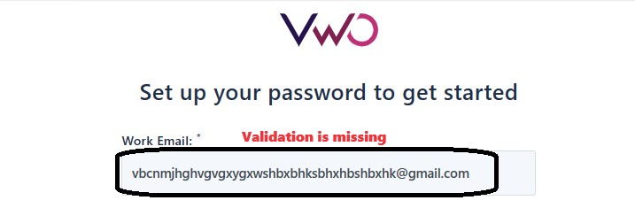

Test case Id - TC-05

Steps to Reproduce

1. Open Application URL <https://app.vwo.com/#/login>
2. Click on Set free trial link
3. Enter Valid Email-id
4. Click on Set free trail account without selecting Privacy Policy checkbox.

Expected Result

The account should not be created without selecting Privacy policy checkbox.

Actual Result

The account is being created without selecting Privacy Policy checkbox

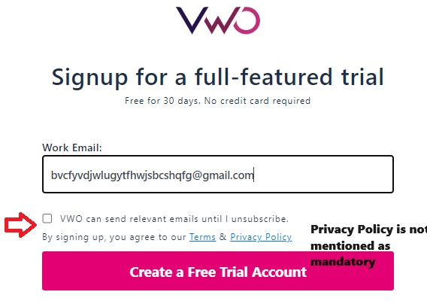

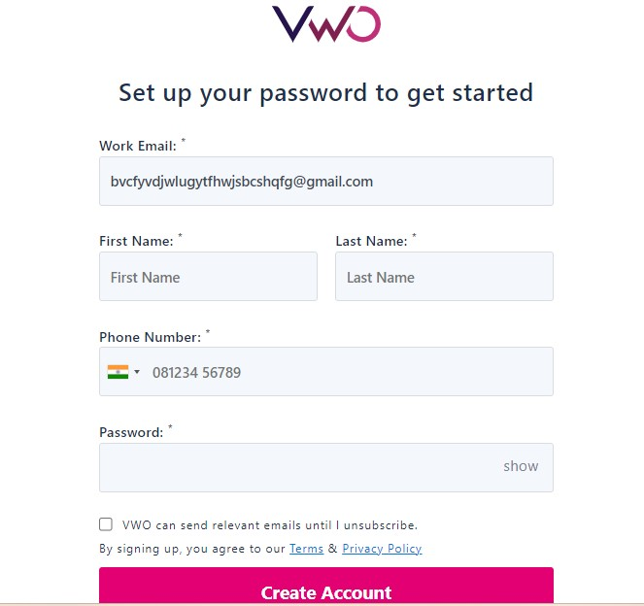

Test case Id - TC-10

Steps to Reproduce

1. Open Application URL <https://app.vwo.com/#/login>
2. Click on Set free trial link
3. Check Privacy Policy is mentioned as mandatory with “*” symbol

Expected Result

All the fields should be mentioned as mandatory including Privacy policy

Actual Result

Privacy policy is not mentioned as mandatory



Test case Id - TC-15

Steps to Reproduce

1. Open Application URL <https://app.vwo.com/#/login>
2. Click on Set free trial link
3. Enter Valid Email-id
4. Click on Privacy policy checkbox
5. Enter First name, Last name (eg. 1234, 456789)

Expected Result

First name, Last name should not accept numbers and its combination as input.

Actual Result

First name, Last name accepts numbers as input.

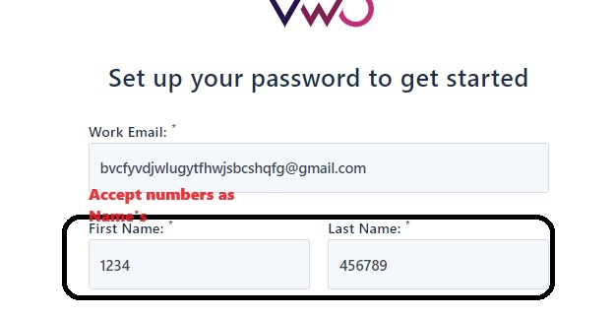

Test case Id - TC-16

Steps to Reproduce

1. Open Application URL <https://app.vwo.com/#/login>
2. Click on Set free trial link
3. Enter Valid Email-id
4. Click on Privacy policy checkbox
5. Enter First name, Last name.

Expected Result

First name, Last name should contain validation, as number of characters allowed, numbers, Combination or Only Alphabets allowed as such

Actual Result

First name, Last name does not have any validation.



Test case Id - TC-25

Steps to Reproduce

1. Open Application URL <https://app.vwo.com/#/login>
2. Click on Set free trial link
3. Enter Valid Email-id
4. Click on Create free trail account.
5. Enter First name, Last name
6. Enter valid Phone number
7. Enter valid Password
8. Click on create account

.

Expected Result

The account creating steps should not be processed further without selecting Privacy policy checkbox, the account should not be created

Actual Result

Account is being created.

